**Video Anomaly Detection with OpenCV and TensorFlow**

**By Nikhil Saroj**

**Overview**

This project demonstrates the implementation of video anomaly detection using OpenCV and TensorFlow. Video anomaly detection involves identifying unusual or unexpected events or objects in a video stream. In this project, we focus on detecting anomalies, specifically the presence of sharks, in a video stream using object detection techniques with a pre-trained TensorFlow model (Faster R-CNN Inception v2).

**Video Source**

The video used for this project is a 11-second clip titled "Great White Shark Breaching" obtained from the stock photo website iStock. The video clip contains a total of 572 frames.

Link: <https://www.istockphoto.com/video/great-white-shark-breaching-gm1314158547-402455395>

**Steps:**

**1. Load Pre-Trained Model Faster R-CNN Inception v2**

This section loads the pre-trained TensorFlow model (Faster R-CNN Inception v2) for object detection using the **load_tf_model** function. The **load_tf_model** function loads the model from the specified path and returns the loaded model.

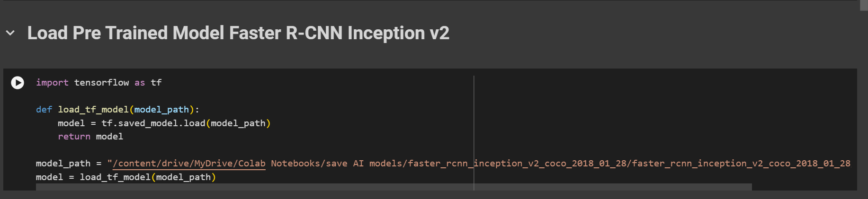

**2. Object Detection in Video Stream**

Object detection is performed on each frame of the video stream using the TensorFlow model. The **perform_object_detection** function preprocesses each frame, performs object detection using the loaded model, and extracts bounding boxes, confidence scores, and classes of detected objects. Bounding boxes are drawn around objects with confidence scores above a specified threshold. Frames with detected objects are marked as anomalies.

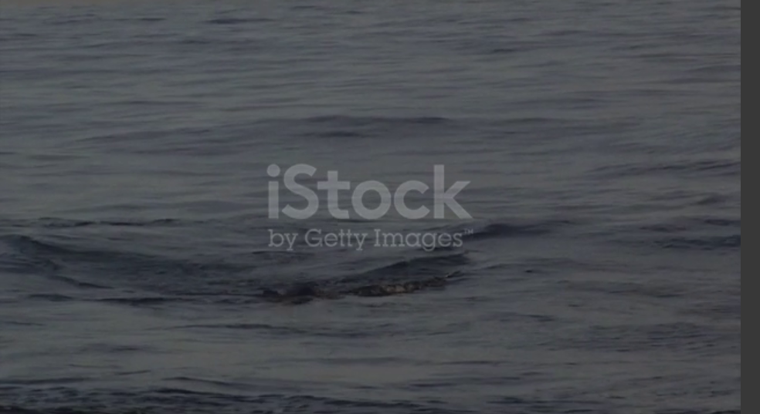

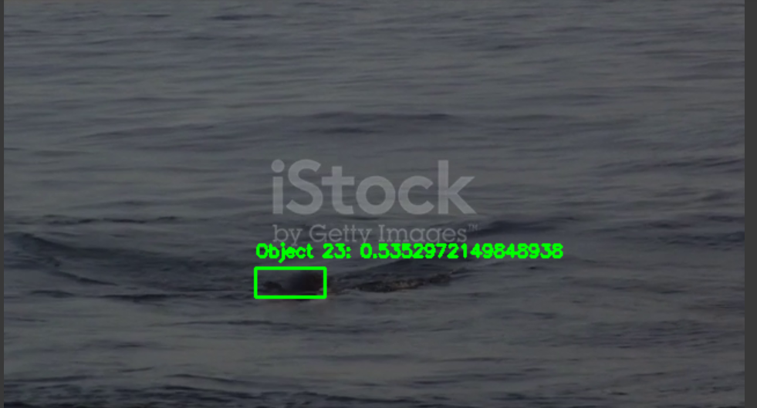

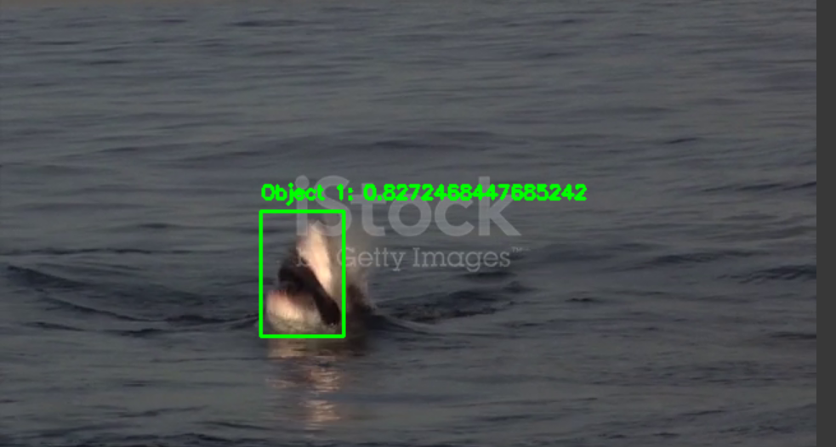

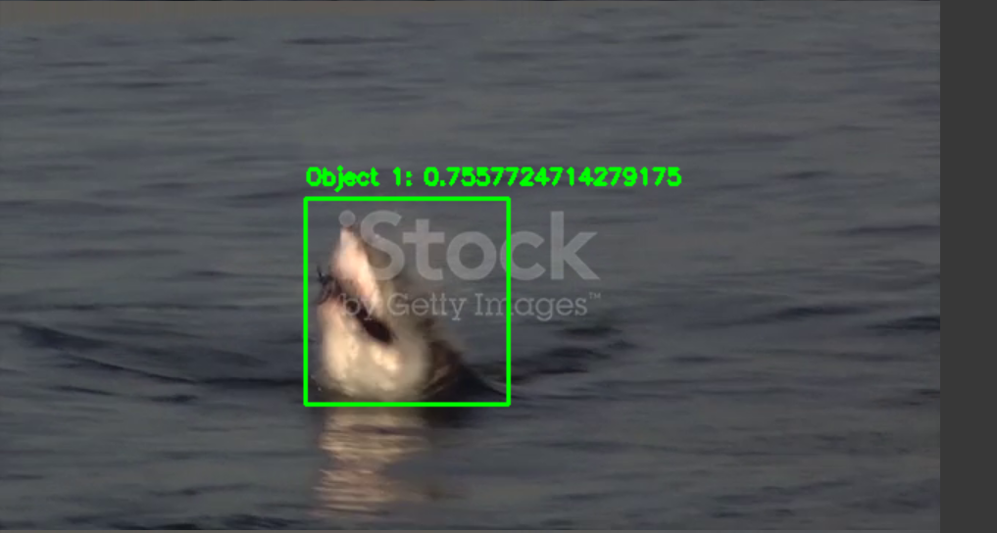

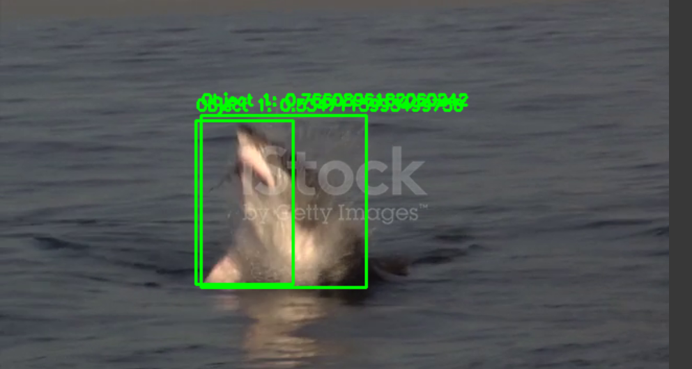

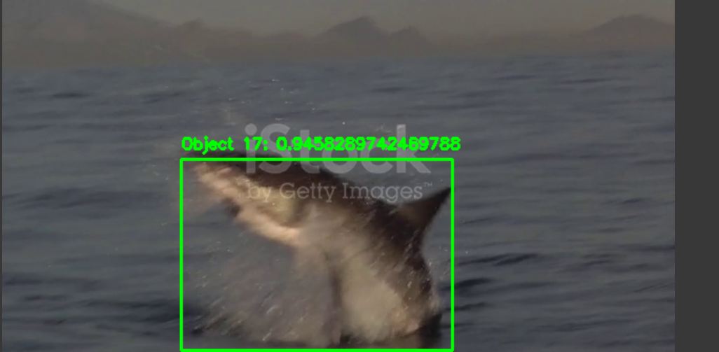

**3. Background Subtraction in Video Stream**

Background subtraction is implemented using the Gaussian Mixture-based Background/Foreground Segmentation method (MOG2) from OpenCV. The **cv2.createBackgroundSubtractorMOG2** function initializes the background subtractor. The **fgbg.apply** function applies background subtraction to each frame, highlighting moving objects. The white bright part is the object detected that is a shark.

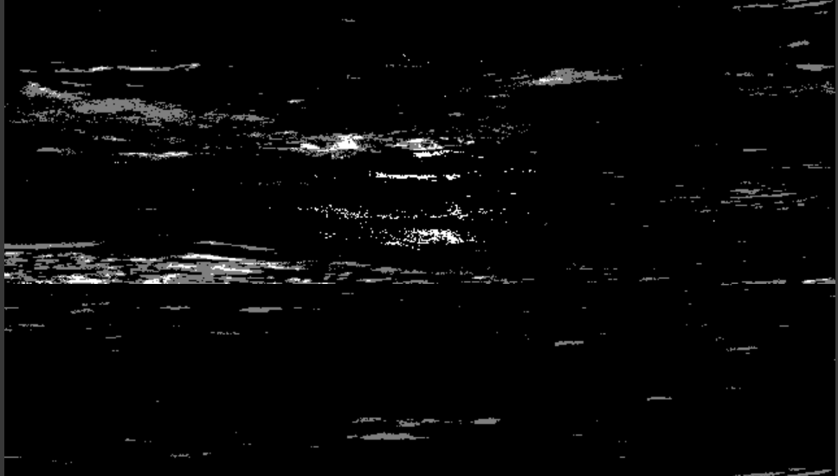

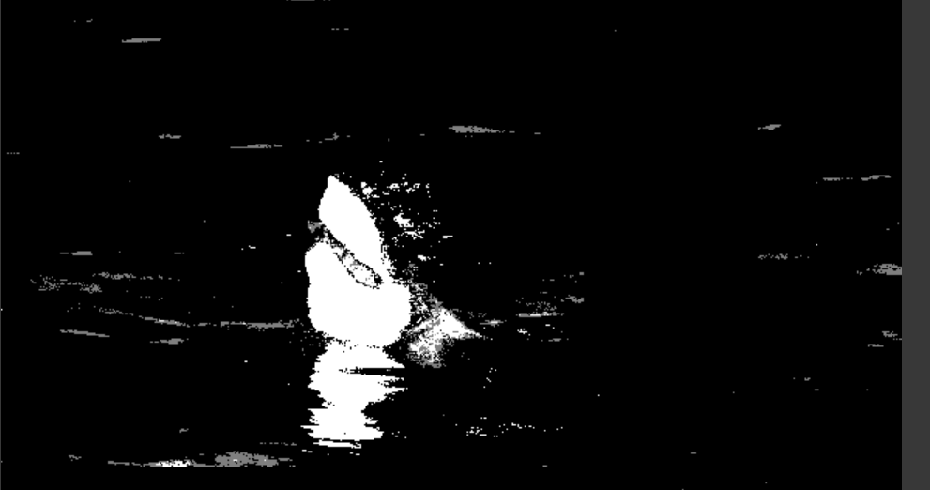

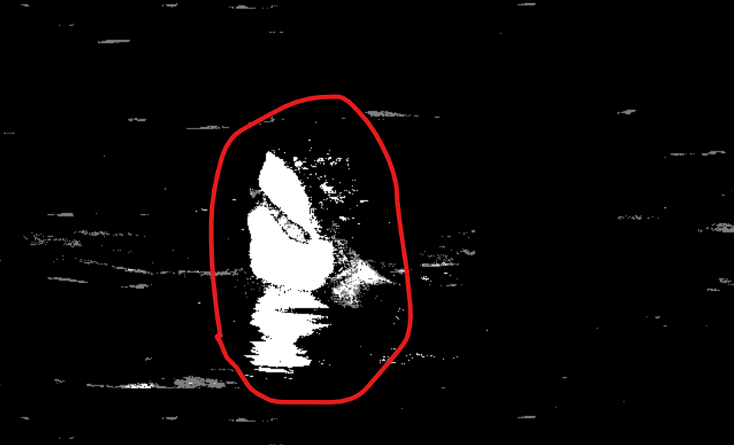

**4. Finding the Restricted Area in Video Stream**

Users can interactively select a restricted area in the video stream by defining four points using mouse clicks. The **get_points** function captures mouse click events and records the selected points. The selected points define the coordinates and dimensions of the restricted area are:

Restricted area coordinates (x, y): 100 100

Restricted area dimensions (width, height): 200 400.

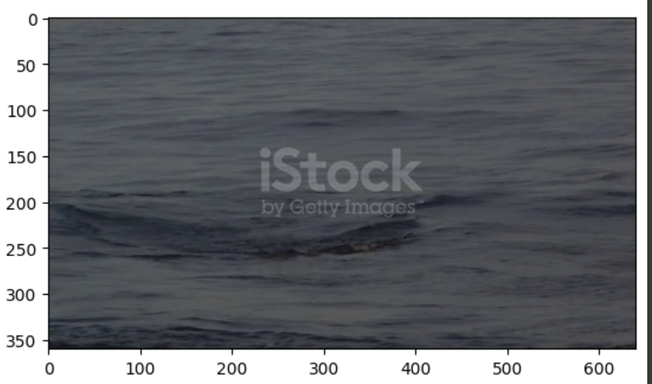

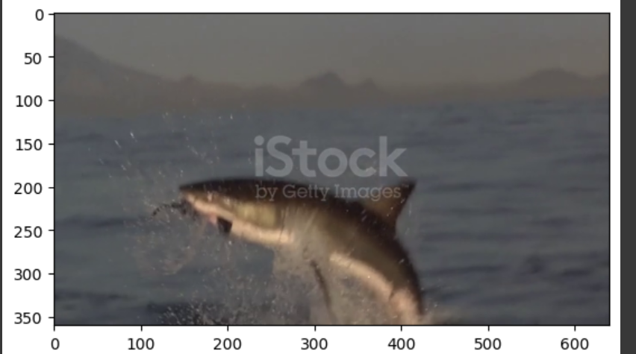

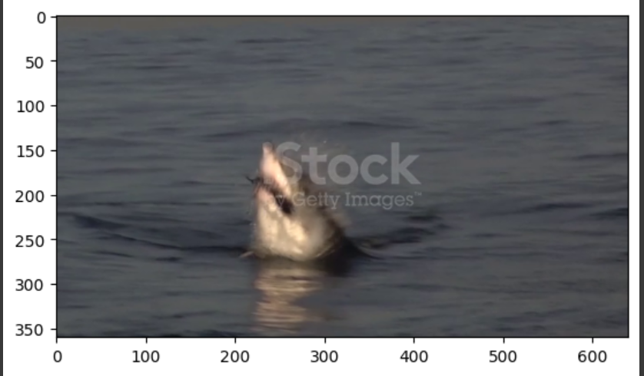

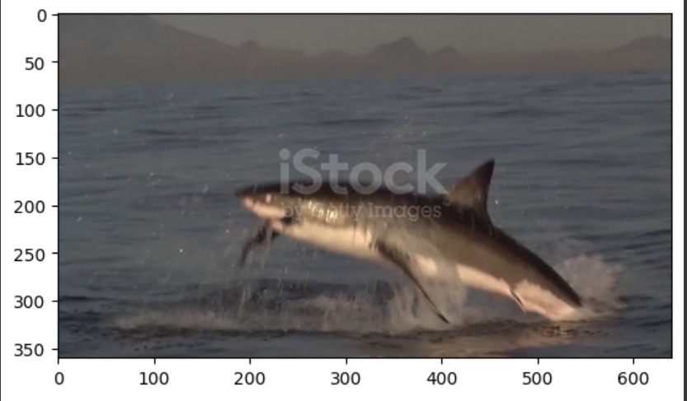

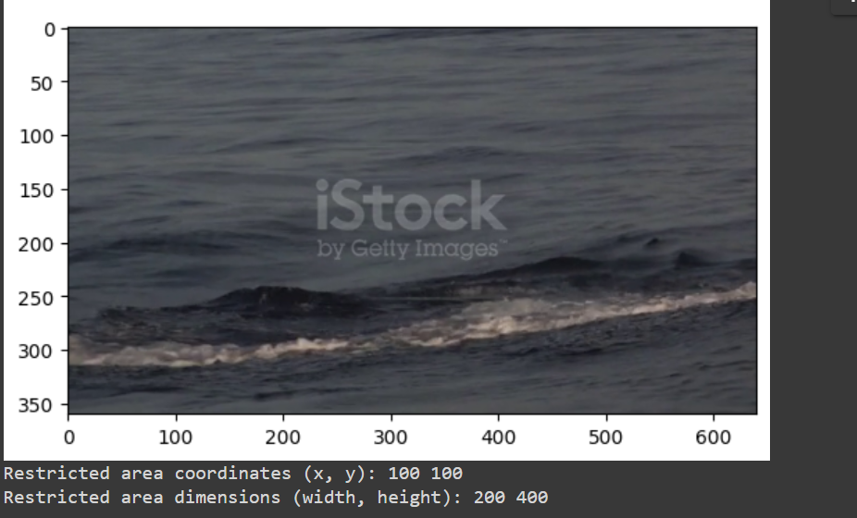

**5. Anomaly Detection in Shark Video using Optical Flow**

Anomaly detection is performed using optical flow between consecutive frames. The **calculate_player_movement_anomaly_scores** function computes anomaly scores for player movements by calculating the magnitude of optical flow vectors between frames. The **detect_anomalies** function detects anomalies based on anomaly scores and a specified threshold. In this project, anomaly scores represent the average flow magnitude, and frames with high anomaly scores are marked as anomalies, indicating the presence of sharks.

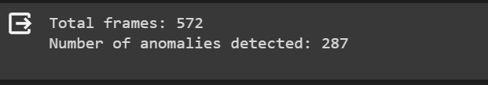

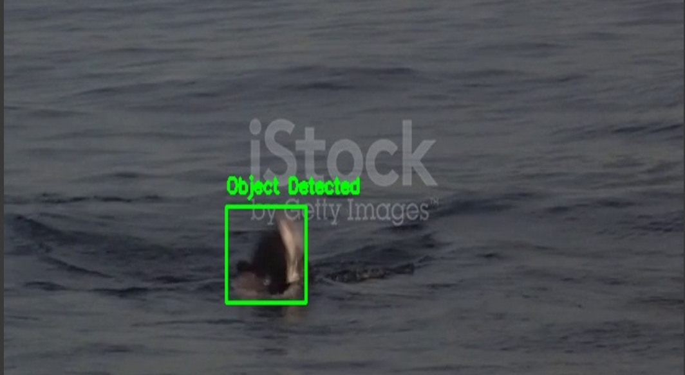

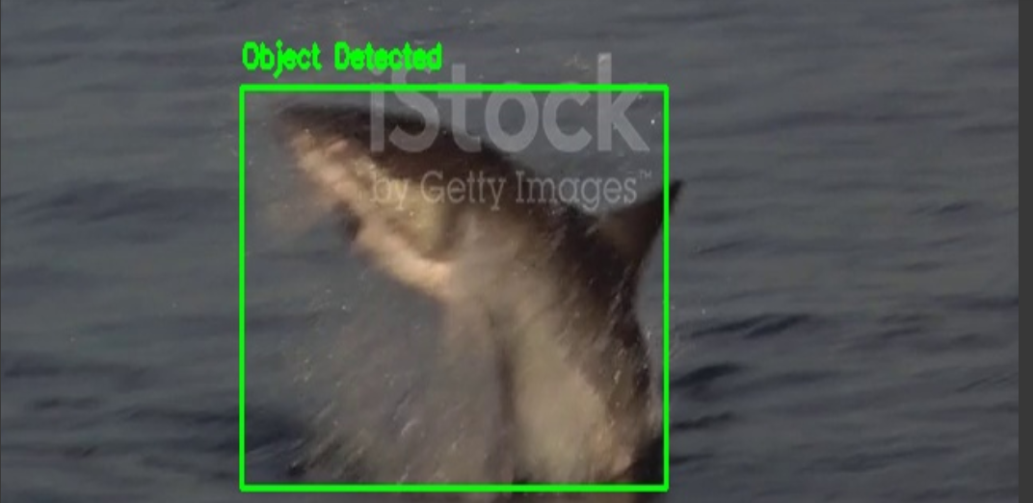

**Total Number of box detected and there Index**

This script performs object detection using a TensorFlow model (Faster R-CNN Inception v2) on each frame of a video stream.

It detects objects with confidence scores greater than 0.5 and draws bounding boxes around them.

The total number of detected objects and the frames where objects are detected are displayed which are need to find **Anomaly Scores:**



Total number of boxes detected: 75

Frames with boxes detected: [257, 258, 259, 260, 261, 262, 263, 264, 265, 266, 267, 268, 273, 274, 275, 276, 277, 278, 279, 280, 281, 282, 283, 284, 287, 288, 295, 296, 297, 298, 299, 300, 301, 302, 303, 304, 305, 306, 307, 308, 311, 312, 313, 314, 319, 320, 331, 332, 333, 334, 335, 336, 337, 338, 341, 342, 347, 348, 349, 350, 351, 352]

**Anomaly Scoring Logic**

In the anomaly scoring logic, each frame of the video stream is analyzed for the presence of detected objects. If objects are detected in a frame, it is marked as an anomaly by assigning a score of 1 to that frame. Frames without detected objects are assigned a score of 0. This approach enables the identification of frames where objects, such as sharks in this case, are present, facilitating the detection of anomalies within the video stream.

**6. Finding the Anomaly Scores**

Anomaly scores are computed for each frame using the optical flow method. Anomaly scores represent the magnitude of motion between consecutive frames. Frames with high anomaly scores indicate unusual movements, such as the presence of sharks:

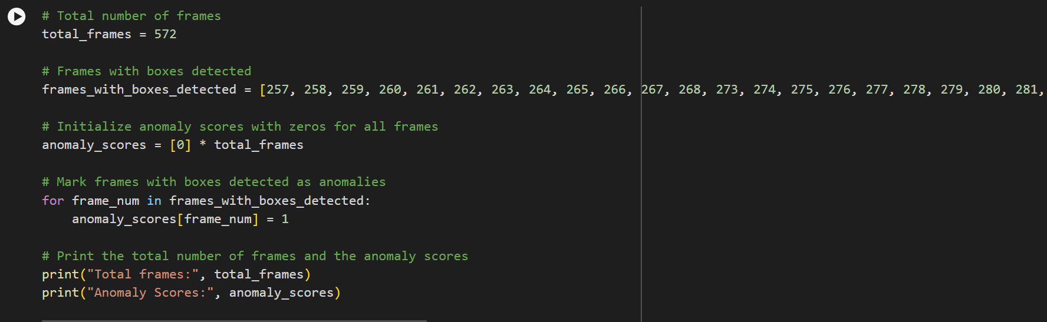



**Total frames: 572**

**Anomaly Scores**: [0, 0, 0, 0, 0, 0, 0, 0, 0, 0, 0, 0, 0, 0, 0, 0, 0, 0, 0, 0, 0, 0, 0, 0, 0, 0, 0, 0, 0, 0, 0, 0, 0, 0, 0, 0, 0, 0, 0, 0, 0, 0, 0, 0, 0, 0, 0, 0, 0, 0, 0, 0, 0, 0, 0, 0, 0, 0, 0, 0, 0, 0, 0, 0, 0, 0, 0, 0, 0, 0, 0, 0, 0, 0, 0, 0, 0, 0, 0, 0, 0, 0, 0, 0, 0, 0, 0, 0, 0, 0, 0, 0, 0, 0, 0, 0, 0, 0, 0, 0, 0, 0, 0, 0, 0, 0, 0, 0, 0, 0, 0, 0, 0, 0, 0, 0, 0, 0, 0, 0, 0, 0, 0, 0, 0, 0, 0, 0, 0, 0, 0, 0, 0, 0, 0, 0, 0, 0, 0, 0, 0, 0, 0, 0, 0, 0, 0, 0, 0, 0, 0, 0, 0, 0, 0, 0, 0, 0, 0, 0, 0, 0, 0, 0, 0, 0, 0, 0, 0, 0, 0, 0, 0, 0, 0, 0, 0, 0, 0, 0, 0, 0, 0, 0, 0, 0, 0, 0, 0, 0, 0, 0, 0, 0, 0, 0, 0, 0, 0, 0, 0, 0, 0, 0, 0, 0, 0, 0, 0, 0, 0, 0, 0, 0, 0, 0, 0, 0, 0, 0, 0, 0, 0, 0, 0, 0, 0, 0, 0, 0, 0, 0, 0, 0, 0, 0, 0, 0, 0, 0, 0, 0, 0, 0, 0, 0, 0, 0, 0, 0, 0, 0, 0, 0, 0, 0, 0, 1, 1, 1, 1, 1, 1, 1, 1, 1, 1, 1, 1, 0, 0, 0, 0, 1, 1, 1, 1, 1, 1, 1, 1, 1, 1, 1, 1, 0, 0, 1, 1, 0, 0, 0, 0, 0, 0, 1, 1, 1, 1, 1, 1, 1, 1, 1, 1, 1, 1, 1, 1, 0, 0, 1, 1, 1, 1, 0, 0, 0, 0, 1, 1, 0, 0, 0, 0, 0, 0, 0, 0, 0, 0, 1, 1, 1, 1, 1, 1, 1, 1, 0, 0, 1, 1, 0, 0, 0, 0, 1, 1, 1, 1, 1, 1, 0, 0, 0, 0, 0, 0, 0, 0, 0, 0, 0, 0, 0, 0, 0, 0, 0, 0, 0, 0, 0, 0, 0, 0, 0, 0, 0, 0, 0, 0, 0, 0, 0, 0, 0, 0, 0, 0, 0, 0, 0, 0, 0, 0, 0, 0, 0, 0, 0, 0, 0, 0, 0, 0, 0, 0, 0, 0, 0, 0, 0, 0, 0, 0, 0, 0, 0, 0, 0, 0, 0, 0, 0, 0, 0, 0, 0, 0, 0, 0, 0, 0, 0, 0, 0, 0, 0, 0, 0, 0, 0, 0, 0, 0, 0, 0, 0, 0, 0, 0, 0, 0, 0, 0, 0, 0, 0, 0, 0, 0, 0, 0, 0, 0, 0, 0, 0, 0, 0, 0, 0, 0, 0, 0, 0, 0, 0, 0, 0, 0, 0, 0, 0, 0, 0, 0, 0, 0, 0, 0, 0, 0, 0, 0, 0, 0, 0, 0, 0, 0, 0, 0, 0, 0, 0, 0, 0, 0, 0, 0, 0, 0, 0, 0, 0, 0, 0, 0, 0, 0, 0, 0, 0, 0, 0, 0, 0, 0, 0, 0, 0, 0, 0, 0, 0, 0, 0, 0, 0, 0, 0, 0, 0, 0, 0, 0, 0, 0, 0, 0, 0, 0, 0, 0, 0, 0, 0, 0, 0, 0, 0, 0, 0, 0, 0, 0, 0, 0, 0]

**7. Setting Thresholds for Anomaly Scores and Trigger Alerts**

In this section, thresholds for anomaly scores are defined to determine when anomalies should be triggered. Anomaly scores represent the likelihood of abnormal activity or objects in the video stream. Two thresholds are defined:

* **Normal Threshold**: Anomaly scores below this threshold indicate normal activity or absence of anomalies.
* **Anomaly Threshold**: Anomaly scores above this threshold indicate the presence of anomalies or abnormal activity.

**Thresholds:**

**Normal Threshold: 0.6**

**Anomaly Threshold: 0.8**

By setting appropriate thresholds, the system can effectively detect and alert users about anomalies in the video stream, facilitating timely responses to unusual events or objects. Adjusting these thresholds may be necessary depending on specific application requirements and the desired balance between false positives and false negatives.

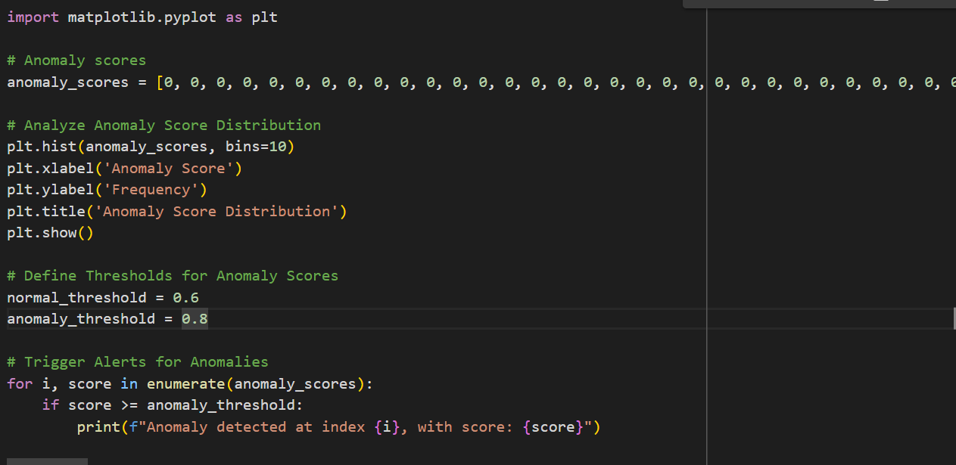

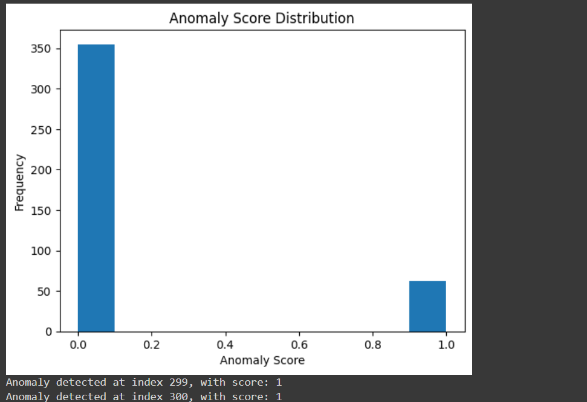

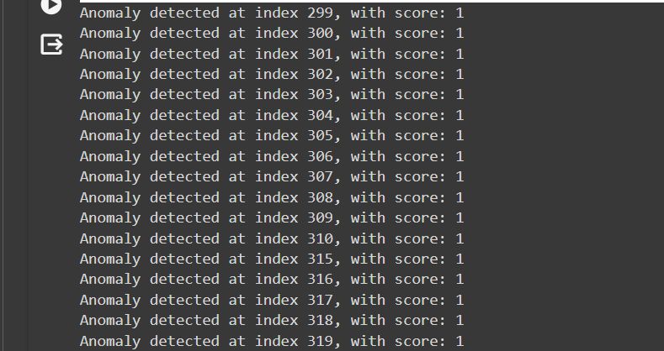

**8. Final Testing Object Detection and Anomaly Detection on Shark Video Stream**

In this section, the object detection and anomaly detection functionalities are thoroughly tested on a shark video stream. The process involves utilizing a TensorFlow model (Faster R-CNN Inception v2) to detect objects, particularly sharks, with confidence scores above 0.5. Frames where sharks are detected are considered anomalies and are marked accordingly.

Testing Procedure:

1. **Loading the TensorFlow Model**: The first step is to load the pre-trained TensorFlow model, specifically Faster R-CNN Inception v2, which is capable of object detection.
2. **Reading Frames from the Video Stream**: The video stream containing footage of sharks is accessed frame by frame using OpenCV.
3. **Performing Object Detection**: Each frame of the video stream is subjected to object detection using the loaded TensorFlow model. Objects with confidence scores exceeding the defined threshold (0.5) are considered for further analysis.
4. **Displaying the Video Stream**: The video stream is displayed in real-time, with bounding boxes drawn around detected objects. If a shark is detected, an indicator is displayed on the frame to alert the user.
5. **Anomaly Detection**: Anomalies are identified based on the presence of detected sharks. If a shark is detected in any frame, it is considered an anomaly.
6. **Alerting**: If an anomaly is detected (specifically, the presence of a shark), a corresponding message is printed to notify the user.

Detailed Explanation:

* **Object Detection**: The TensorFlow model is employed to perform object detection on each frame of the video stream. Bounding boxes are drawn around objects with confidence scores greater than 0.5. If a shark is detected, the frame is marked as an anomaly.
* **Displaying Results**: The video stream, along with bounding boxes and anomaly indicators, is displayed in real-time using OpenCV. This allows for immediate visual inspection of the detection results.
* **Anomaly Detection and Alerting**: Anomalies, in this case, the presence of sharks, are detected in real-time. If a shark is detected in any frame, an alert message is printed to notify the user of the anomaly.

**Output**:



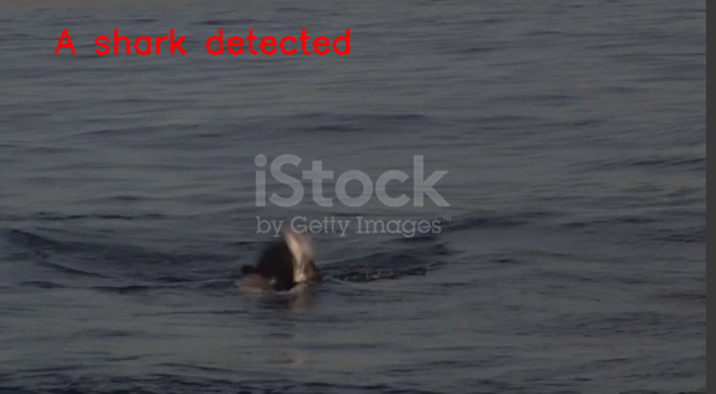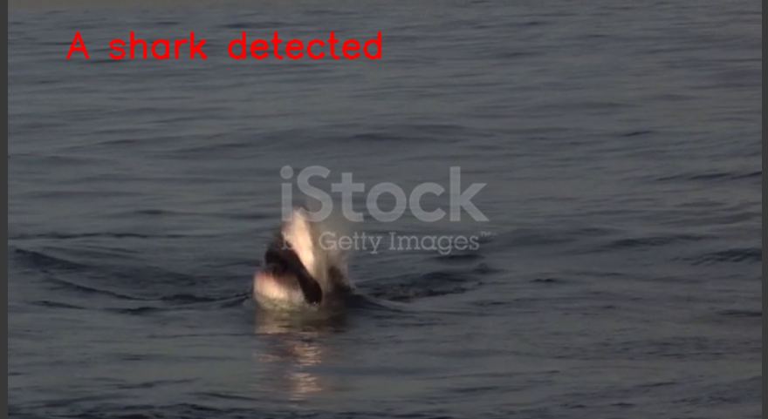

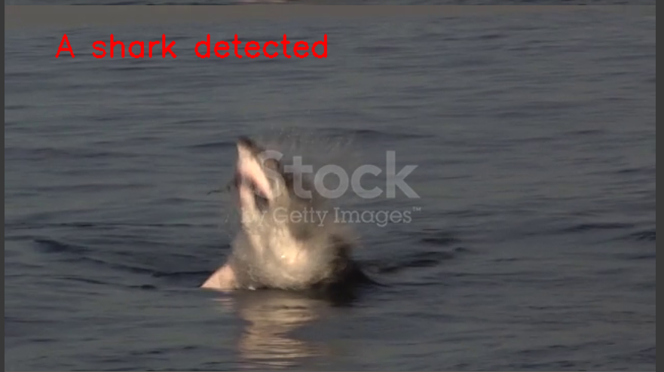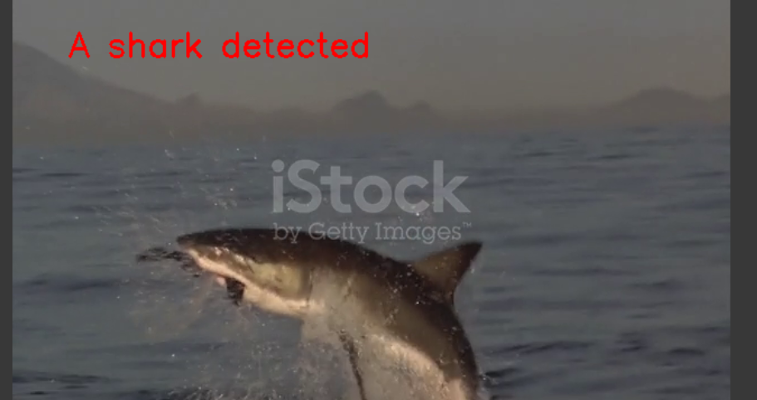

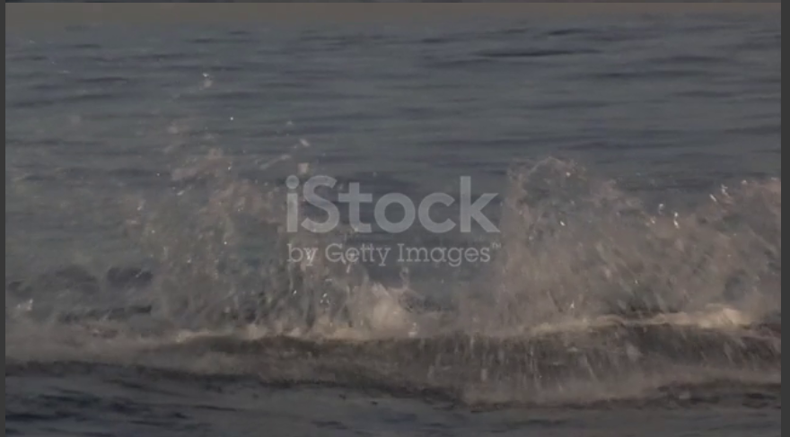

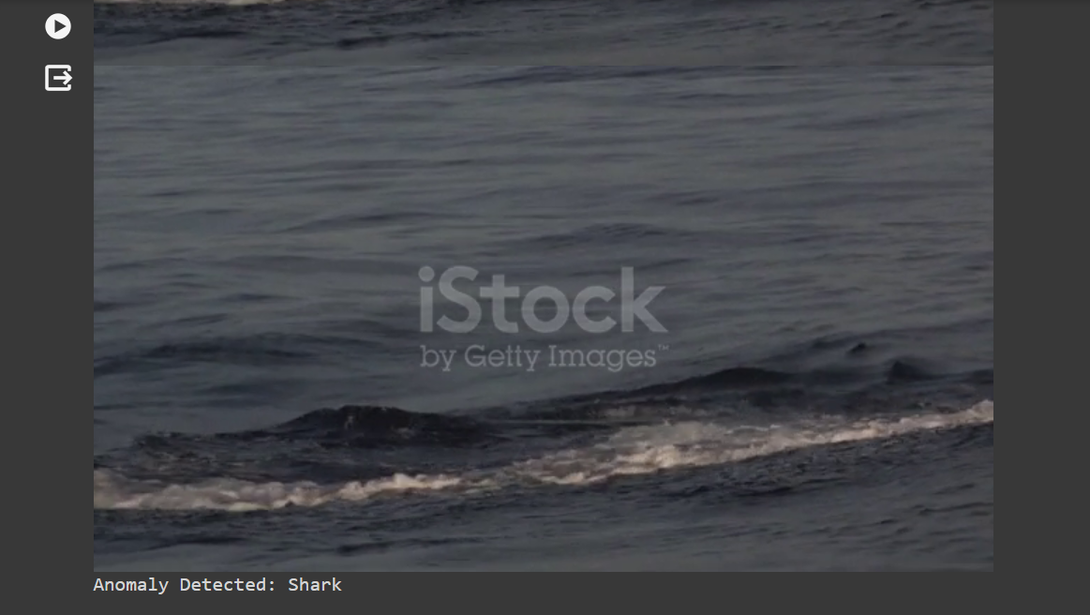

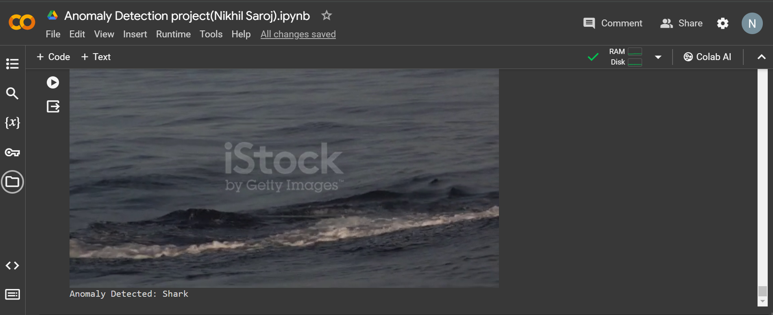

**Shark Detection in Video Stream using TensorFlow and OpenCV and to Save the Video**

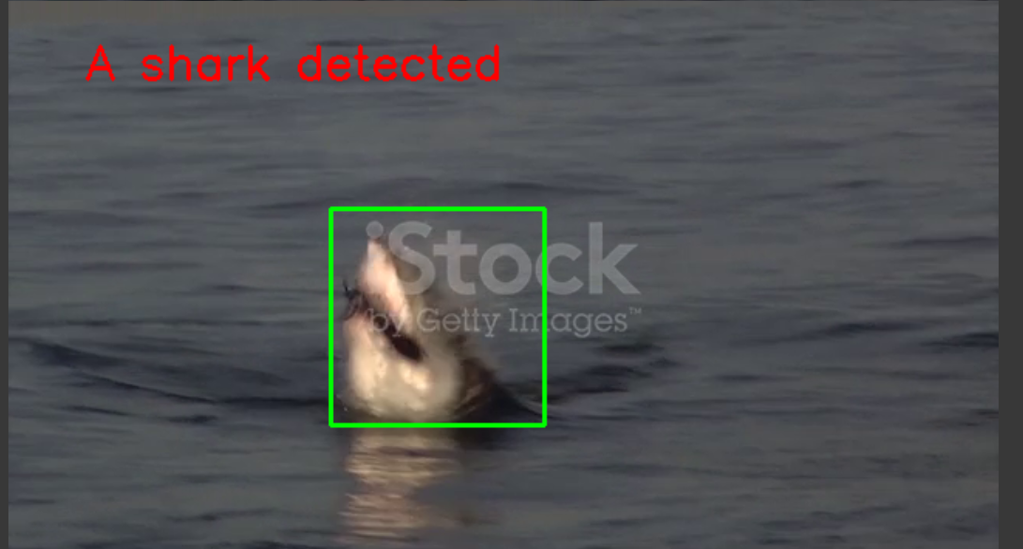

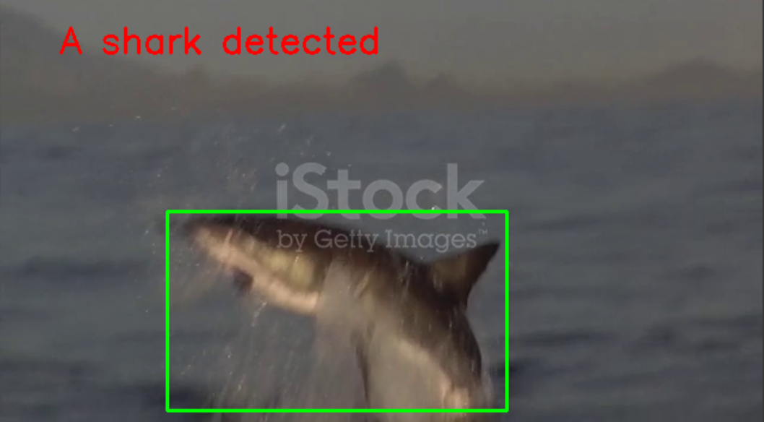 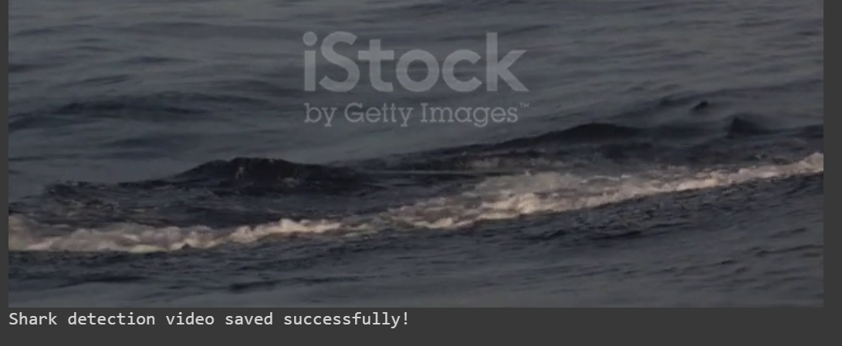

**Conclusion**

In conclusion, this project has allowed me to delve into the fascinating realm of video anomaly detection using OpenCV and TensorFlow. By focusing on detecting anomalies, particularly the presence of sharks, in a video stream, I've had the opportunity to explore the intricacies of object detection techniques with a pre-trained TensorFlow model (Faster R-CNN Inception v2).

This project has been a valuable learning experience for me, providing insights into video processing and anomaly detection algorithms. It has equipped me with practical skills and knowledge that are applicable in various real-world scenarios, especially in the context of drone technology.

I am grateful to Vyorius Drone Private Limited for entrusting me with this assignment during my internship selection process. Working on this project has not only allowed me to showcase my abilities but has also prepared me for future challenges in the industry.